DATE:
Name: | D.O.B:
Address: | Email:
 | Tel. (Home) No: Tel. (Mobile)No:
 | Preferred method of contact:
Emergency contact: | Children: (ages now)
Occupation/Type of work: |  | Hours of work:
Any caring responsibilities?

MEDICAL HISTORY
Current medical conditions recorded with GP. (Aches and pains you have now or had in the last few weeks.)
Past operations: (right back to childhood)
Medications:
& Supplements:
Allergy to any products?
Name & Address of GP
LIFE STYLE
Do you manage to exercise regularly? | YES/NO |  | What activities do you do? (hours/week)
Smoking | YES/NO |  | Type.
Alcohol | YES/NO |  | How much?
Pregnant (please tick) | Menstruating |  | Menopause
Diet
Fluid intake | How many cups of tea/ coffee / water? Per day
Sleep | How many hours? Do you wake? And what at time?
Relaxation | What do you do to relax?
Work Stress Levels |  | 1-2-3-4-5-6-7-8-9-10
Home Stress Levels |  | 1-2-3-4-5-6-7-8-9-10
Energy Levels |  | 1-2-3-4-5-6-7-8-9-10
Is anything specific stressing you or upsetting you?

THOUGHTS BEFORE YOUR TREATMENT
How do you feel about your feet?

What do you want to gain from Reflexology?

Where did you hear about the Vale Reflexology Clinic?

Thank you for filling out this form - It allows me to adapt your treatment appropriately from the first session.
No personal data is stored online – No personal information will be held beyond 12 months of your last treatment.
Please feel free to call me if you have any questions

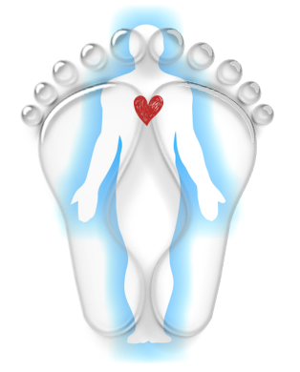





V A L E
kim@valereflexology.co.uk
07885 479048
REFLEXOLOGY
V A L E
kim@valereflexology.co.uk
07885 479048
REFLEXOLOGY

